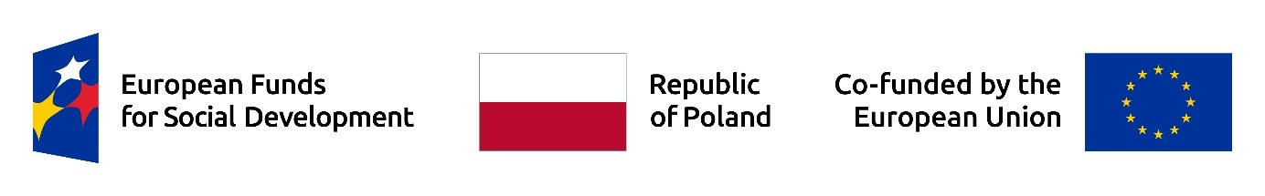

Data privacy statement of VIZJA University for persons participating in the recruitment process and project support:
In accordance with Articles 13 and 14 of the Regulation (EU) 2016/679 of the European Parliament and of the Council of 27 April 2016 on the protection of natural persons with regard to the processing of personal data and on the free movement of such data, and repealing Directive 95/46/EC (General Data Protection Regulation – hereinafter “GDPR”, OJ EU L 2016 No. 119), we inform that:
- The controller of your personal data is VIZJA University, located at ul. Okopowa 59, 01-043 Warsaw, e-mail address: zgloszenia@vizja.pl
- Your personal data will be processed solely to the extent and for the purpose necessary for the implementation of the project entitled “Towards Excellence – Systemic Support for the Development of Teaching at the University” (hereinafter the “Project”) under the implementation of agreement no. FERS.01.05-IP.08-0204/25, as well as for the legal obligations of the controller, based on:
- Art. 6(1)(c) of the GDPR and Art. 9(2)(g) of the GDPR, necessity to fulfill legal obligations arising from provisions of law, in order to qualify you for participation in the Project entitled “Improving Academic Efficiency: University Management and Drop-out Reduction” (project no: FERS.01.05-IP.08-0103/25), implemented under the European Social Fund for Social Development 2021-2027 Program, adopted by the European Commission on 12 December 2022, co-financed from the European Social Fund Plus (“FERS”), to contact you during the recruitment process, verify the completeness of documents, implement project support for qualified individuals, and for Project accounting and evaluation purposes.
- Art. 6(1)(f) of the GDPR, for purposes necessary to establish, pursue, or defend against potential claims.
- Personal data, including voice and image, may be processed for informational, promotional, and documentation purposes related to the implementation of the Project, based on the consent given, Art. 6(1)(a) of the GDPR.
- Personal data have been collected directly from you or from institutions and entities involved in the implementation of the Project.
- The collected personal data include categories of identification and contact data specified in Art. 87 of the Act of 28 April 2022 on the Principles of Implementing Tasks Financed from European Funds in the 2021-2027 Financial Perspective: first and last name, date of birth, citizenship, gender, PESEL, e-mail address, residential address, place of work, phone number, position, education, professional status, labor market status (employed, inactive, unemployed), data concerning special needs and disabilities.
- Your personal data may be transferred to public authorities and government offices or other entities authorized under the law. Personal data may be transferred by us to entities operating the controller’s IT systems and providing IT tools, or providing services such as postal, courier, cloud, document destruction, or hosting. Data may be transferred to the Minister responsible for regional development and to the National Centre for Research and Development and IT systems provided by them for data collection, such as the ESF Monitoring System (SM EFS). Your data may be made available to experts, entities conducting audits, inspections, evaluations, institutions, authorities and agencies of the European Union (EU), as well as other entities entrusted by the EU with tasks related to the implementation of the European Social Fund for Social Development 2021-2027 Program, adopted by the European Commission on 12 December 2022, co-financed from the European Social Fund Plus.
- Based on your personal data, the Controller will not make automated decisions, including decisions resulting from profiling within the meaning of the GDPR.
- Your personal data will be processed for the duration of the Project, unless a longer processing period is necessary, e.g., due to evaluation, archiving obligations, or limitation periods for claims. Your personal data will be stored for a period of 5 years from 31 December of the year in which the final payment request under the Project was approved, provided that the period is suspended in the event of the initiation of administrative or judicial proceedings regarding expenditures settled under the Project or at the duly justified request of the European Commission.
- You have the right to request from the controller access to your personal data, their rectification, deletion, or restriction of processing.
- You have the right to withdraw your consent at any time by sending a statement of withdrawal of consent to the e-mail address: zgloszenia@vizja.pl.
- You also have the right to lodge an objection.
- You have the right to lodge a complaint with the supervisory authority, i.e., the President of the Personal Data Protection Office.
- Providing your personal data is required to participate in the recruitment process for the Project and, after being qualified, to participate in the Project. Refusal to provide personal data will result in the inability to participate in the recruitment process for the Project, participate in the Project, and use the support forms under the aforementioned Program.
- Your personal data will not be transferred to a third country or an international organization unless required by the legal obligations of the Controller.

